Report 10, Spike Train

Seqian Wang, In Collaboration with Sulantha Mathotaarachchi and Maxime Parent

# Part I: Spike Train Statistics

## A) Spike Train Binary Representation

1) Vm was sampled at 10417Hz ()

2) With a threshold of -20mV, I get 2026 spikes by finding all time points where Vm is higher than threshold and the one just before is not.

3) By dividing the spike train by the timesteps provided, it is possible to determine whether at least one “action potential” occurred per timestep. With a higher timestep value (, more timepoints are 1.

## B) Interspike Interval Statistics

1) The diff function is particularly helpful here.

2) ISI Histogram

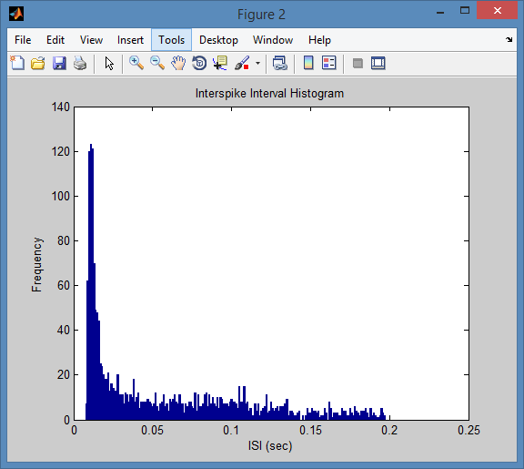

3) With a CV of 1.0416, the neuron activity is slightly more variable than the Poisson process (which has a CV of 1).

4) Interspike Interval Correlation Coefficient: As can be seen in the figure below, the isi correlation coefficient is around 0 over most of the time, suggesting that the spike train is not a renewal process.

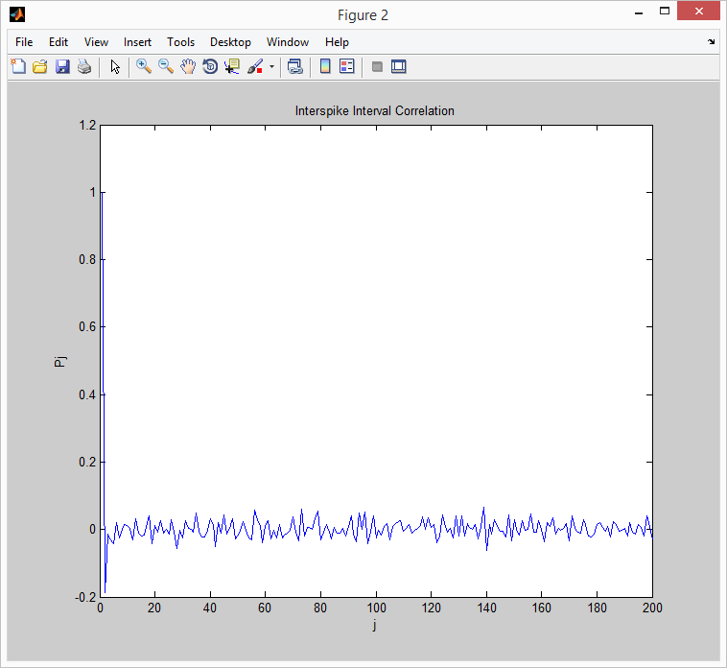

## C) Autocorrelation function and Power spectrum

?

# Part II : Measures of Neural Encoding

## A) Raster plots and PSTH

1) Raster Plot, Showing the neuronal response to a stimulus over many trials

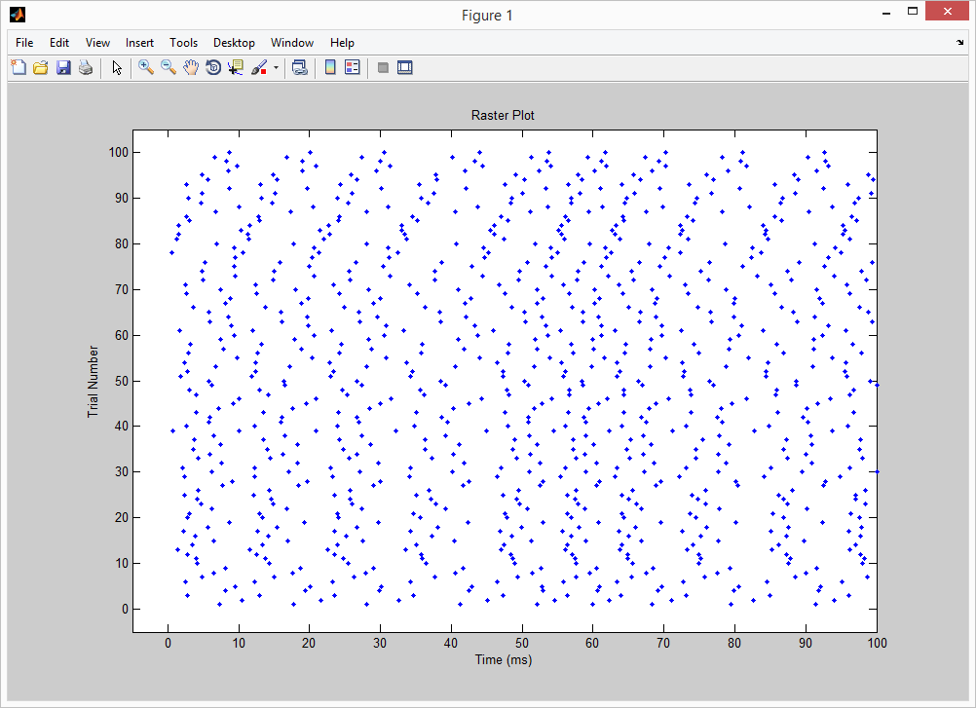

2) PSTH, Shows the average responses at a given time for a given stimulus

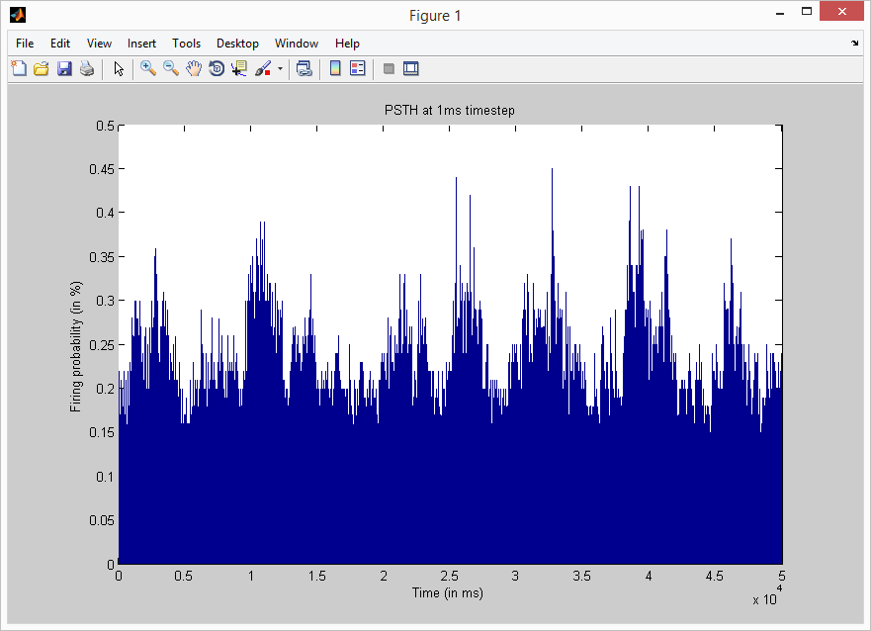

## B) Cross-correlation function and transfer function

1) Cross-Correlation Functions. The cross-correlations between the Stimulus and Trial 1, 20 and all (average) is fairly similar, suggesting that the relation between the stimulus and neuronal response is stable and consistent across trials.

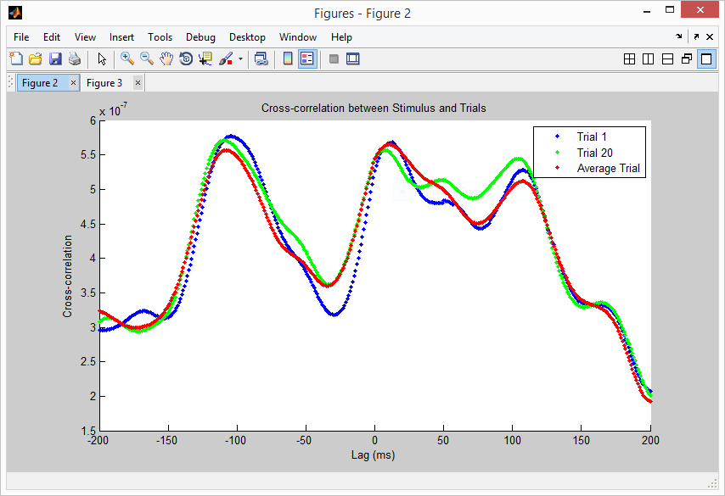

2) Cross-Spectrum Function. The spectral magnitude is high at lower frequencies (<4Hz). This suggests that the periodicity between the stimulus and response is around these frequencies.

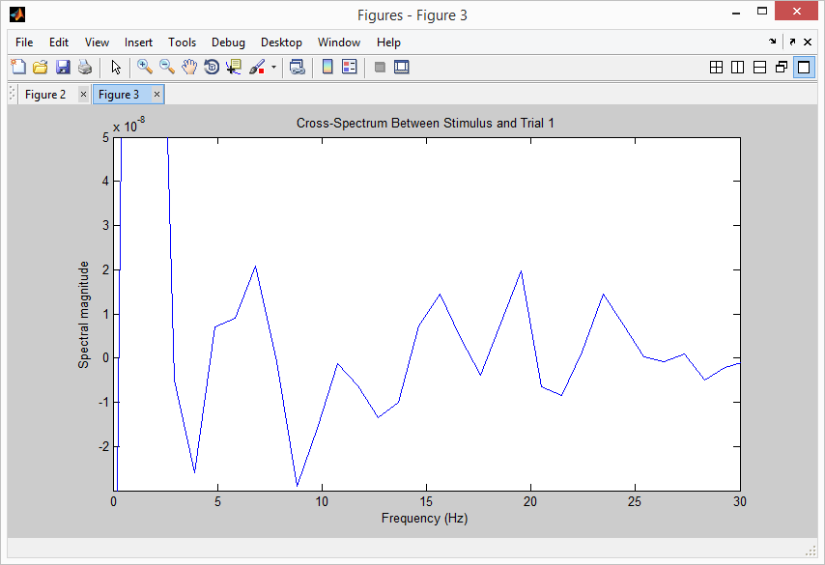

## C) Signal-to-noise Ratio

1) To calculate the Signal-to-Noise ratio (not shown here because I didn’t manage to make it work), we need to find the mean and noise power spectrum (shown below). The mean spectral is magnitudes higher than the noise, so one would expect signal-to-noise ratio to be great.

